**Exercise 5 - Deploy your chatbot on your website or a Fiori Launchpad with the SAP Conversational AI Web Client**

The SAP Conversational AI Web Client is a conversational user interface for connecting to SAP Conversational AI chatbots via the SAP Conversational AI Web Client channel. It is a rich web client capable of rendering the bot responses using SAP Fiori-compliant UI controls.

## **Step 1: Create a channel**

Go to the **Connect** tab of your bot and create an **SAP Conversational AI Web Client** channel.

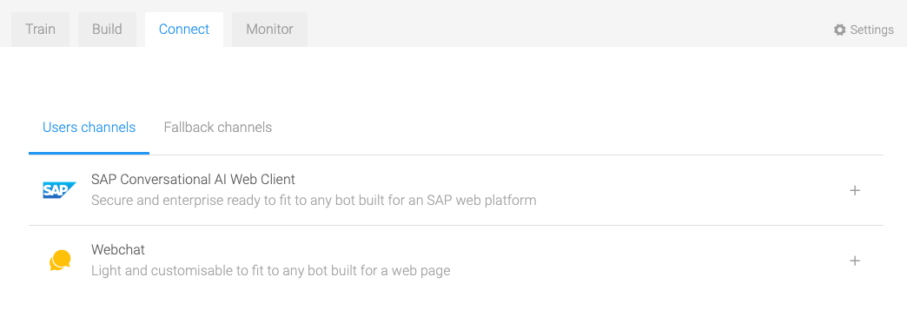

**Step 2: Integration settings**

The SAP Conversational AI Web Client offers two methods of integration. The first uses a snippet with a single channel ID, and the second uses an application ID.

***Option A: Using a Snippet with a Single Channel ID***

Context  
When the SAP Conversational AI Web Client connects to a single channel, it can be integrated into any Web page, without requiring user authentication.  
  
Procedure  
Simply provide a technical name for your channel and paste the provided snippet (displayed when you hit Create) into your Web application. You’re now ready to chat with your bot.

## ***Option B: Using an Application ID*** Prerequisites To use the application ID method, the SAP Conversational AI Web Client needs to be integrated into the main Web application or application shell of a supported SAP product (for example, the SAP Fiori launchpad of an SAP S/4HANA system) or into a Web application that meets the same security and authentication requirements. [For information on requirements and the integration process, read the Configurating Guide on the SAP Help Portal.](https://help.sap.com/viewer/eafc53387d0d46a887611a1f48ca6d23/latest/en-US/8f6ce03bc9ec472dbb15e575b02cfea1.html) Context The application ID method offers a very flexible way of mapping a channel to a given Web application. It also supports mapping of multiple channels to a single SAP Conversational AI Web Client. When you use this method, end users are offered a channel selection menu when they open the web client. Procedure Provide two mandatory parameters and one optional channel title:

|  |  |  |
| --- | --- | --- |
| **Field** | **Description** | **Example** |
| **Name** | The technical name of the channel | my-new-channel |
| **Application ID** | The ID of the application where the SAP Conversational AI Web Client is integrated. The application ID depends on the type of SAP product or the type of integration (snippet or preintegrated).  For SAP S/4HANA systems with SAP Fiori launchpad as the front end, the application ID is <BOT_OWNER><SID><CLIENT>.  The application ID will automatically be prefixed with the bot owner slug (the user or organization owning the bot) to ensure its uniqueness. | org-ABC123 |
| **Channel Title** | A title that will be displayed in the channel selection menu when more than one channel is mapped to a given application ID. | My Channel Title |

**Step 3: Customizing your channel**When using snippet integration (either for a single channel or with an application ID), you can customize the look and behavior of your SAP Conversational AI Web Client.

* **Color Scheme**You can either use the default SAP theme or create your own custom scheme by specifying the different basic and accent colors to be used.
* **Header Customization**You can define the header title and logo of the web client.
* **Message Settings**You can define the pictures that are displayed next to the bot replies and user messages. You can also define the input placeholder as well as a welcome message that will be displayed each time the user opens the SAP Conversational AI Web Client.
* **General Settings**The **General Settings** let you define the following:
  + The lifetime of a conversation with a bot
  + The language of your permanent static menu if you have created one
  + The behavior of the web client when the Web application is opened by the user
  + The maximum length of a user message

For more information about the SAP Conversational AI Web Client, [please read our documentation.](https://help.sap.com/viewer/a4522a393d2b4643812b7caadfe90c18/latest/en-US/77bb849c7f2b4648ae13ae1d212507d2.html)